1. A black text on a white background

   Description automatically generated
2. 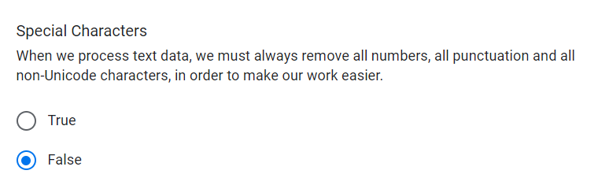
3. A screenshot of a computer

   Description automatically generated
4. A screenshot of a computer

   Description automatically generated
5. A screenshot of a computer

   Description automatically generated

Link:  <http://www.gutenberg.org/files/1342/1342-0.txt>

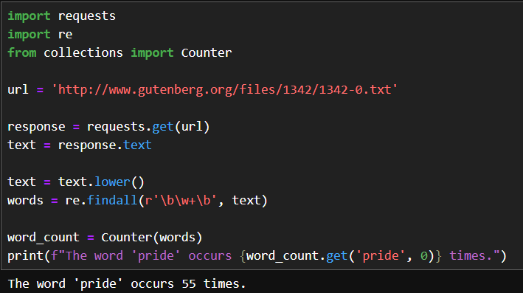

1. A computer screen shot of a program

   Description automatically generatedA screenshot of a computer

   Description automatically generated
2. A white background with black text

   Description automatically generated

